First Baptist Church Manassas  Our Kingdom Mandate is to become the salvific love image of God in Jesus the Christ. We care about and serve the neighbors Jesus misses most, becoming indispensable to our communities and beyond. We listen to the leading of the Spirit of God, as our Lord God leads us into a fresh meaning of faith, expectancy, evangelism, praise, worship, discipleship, and servanthood. What does it look like? Committed to Christ (a family relationship of worship beyond Sunday). Biblically Measured (learning & living by biblical truth and daily prayer). Family-Centered (wholeness that connects & cares for each other). Gospel Boldness (invest & invite to show the way as a living witness). Social Justice Responsibility (the lives of those around us are our business). Cheerful Servanthood (serve and impactful generosity). |  |  | 2024  Prayer & Fasting  Daniel-Fast Guide  February 15 – March 6, 2024
Contact us  9258 Center Street  Manassas, Virginia 20110  Phone 703.368.2935  Email fbcadmin@fbcmanassas.org  Web www.fbcmanassas.org  Follows us on Facebook, Instagram, and YouTube |  |  | 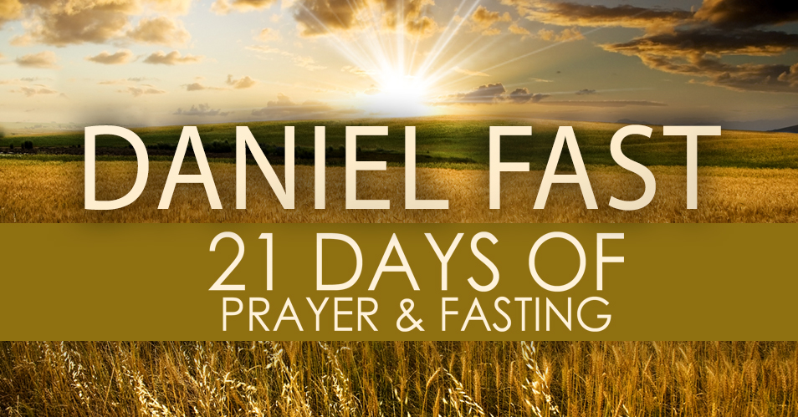
kingdom mandate:
Discipled People, Serving People, Into a Love Relationship with Jesus Christ

Table of contents  What is prayer & fasting and why pray and fast? 1  Are there different types of fasting? 2  Spiritual preparation and prayer requests 3  Managing your schedule 4  Make your spiritual experience a great experience 5  FBC and Contact Information Back Page  True Christian faith requires prayer and fasting. We fast for strength to resist the devil, to weather the storms of life, for greater faith and staying power to wait on the Lord. When disciples of Christ pray and fast together, the Lord leads and lifts us to greater faith in being the light and salt of the earth in our personal walk, in our families, in First Baptist Church, and in the world. |  |  | Make It a Great Experience
Receiving God’s best from a prayer and fasting experience requires solid commitment. Arranging special time each day with God is crucial. Devote yourself to seeking God’s face, even (and especially) during those times in which you feel weak, vulnerable, or irritable.
Read God’s Word and pray during times when hunger sets in. Sing praises to God. Focus on your Heavenly Father and the purpose of this prayer and fasting time.
 |  |  | 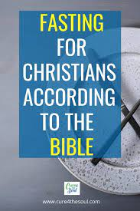 |  | As you enter this time of spiritual devotion, be aware the enemy will do everything to pull you away from your prayer and Bible reading time. When you feel the enemy trying to discourage you, go to God in prayer and ask for strength in the face of temptations and trials. The enemy makes you a target because the enemy knows that fasting is a powerful Christian discipline and God may have something very special to show you as you wait on the Lord.
 |  |  | 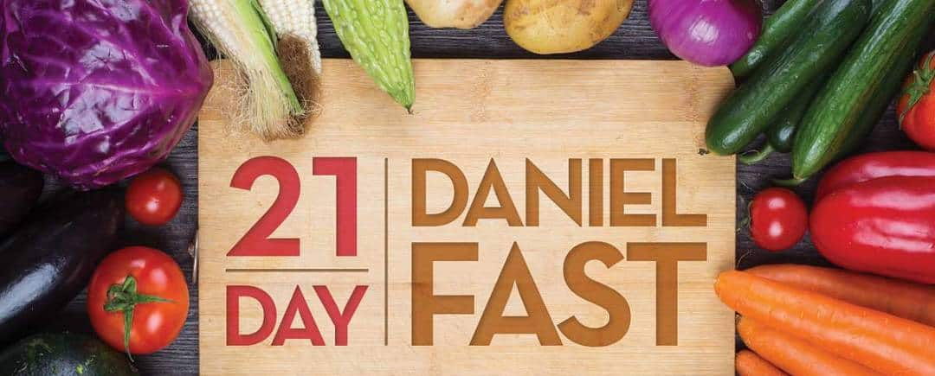 |  | Prayer: Lord, help me to joyfully give up earthly pleasures and the desires of the flesh so that my prayers may be more powerful and effective. In Jesus’ name I pray. Gaining God’s vision and wisdom becomes clear only when the church is engaged in spiritual practice.
 |  |  | 5

Managing Your Schedule  How you adjust your work schedule depends mostly on your occupation. Some may work in occupations that require strenuous physical labor, if so, you may wish to fast less days of the week,  Pricing  Throughout your fast, you may feel weaker than normal. During the first few days, you may feel tired and irritable during the middle of the day. If possible, easing your workload and engaging in a strenuous exercise would be a good idea to maintain your health and morale. Usually, your energy will return.  Make it picture perfect  Fasting is not just the denial of food. It is exchanging the needs of the body for those of the Spirit. Prayer and reading God’s Word will be essential if you are to enter intimate communion with God.  While fasting, if you waste energy on errands or busy-work to the neglect of spending special time with God, you will starve the body and spirit. You will become discouraged and frustrated instead of being spiritually uplifted and blessed. |  |  | Prayer and Fasting  Desserts and baked goods
 |  |  | 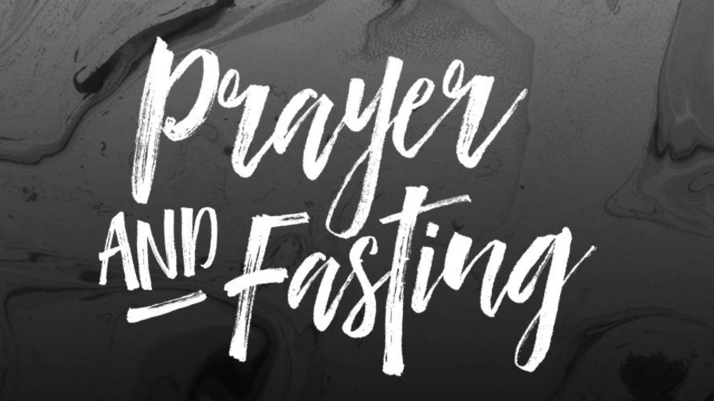 |  | Prayer & Fasting is a discipline practiced in the Bible. It’s voluntarily going without food to focus on God. It’s not a way to manipulate the Lord, but a way to encourage you to rely on the Lord for strength and provision. It gives God control of your heart, mind, body, and soul in order to pray, read, and meditate on the Word of God in a new and powerful way.
 |  |  | Buffet-style meals
 |  |  | 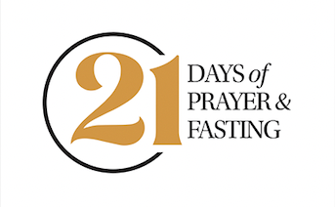 |  | As hope sustains you in suffering, so the Holy Spirit is our help in prayer. You enter a deep communion with God, freeing yourself to pray for God’s will in all things. In prayer and fasting, the Holy Spirit leads you and FBC into new obedience, renewal, and revelation of God’s mission and ministry. A church family in unified prayer and fasting becomes a powerful kingdom of God force in the world
 |  |  | Plated dinners
 |  |  | 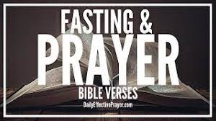 |  | Exodus 34:27-28 Leviticus 16:29  Judges 20:25-26 1 Samuel 7:6; 31:12-13  2 Samuel 12:15-16 1 Kings 21:27-29  2 Chronicles 20:1-3 Ezra 10:6  Nehemiah 1:3-4 Esther 4:3, 15-16  Daniel 6:18-22a; 9:1-3; 10:1-3 Jonah 3:4-5  Matthew 6:16-18; Mark 2:18-20; Luke 2:36-37; Acts 10:30-31; Acts 13:1-3; Acts 14:21-23
4 |  |  | 1

Different Types of Fasting  The biblical recounts various fasts.  The Hebrew prophet Daniel went on a partial fast in which he only abstained from choice meats (Daniel 1:11-16; 10:3). The Apostle Paul went on a fast for 3 days without eating or drinking, following his encounter with the resurrected Jesus on the road to Damascus (Acts 9:9). Jesus, Moses, and the prophet Elijah engaged in supernatural fasts of 40-days (Deuteronomy 9:9; 1 Kings 19:8).  What we do best  First Baptist Church will move into a partial 21-day “Daniel” fast in which we abstain from meats and seafood between the hours of 9:00 a.m. to 5:00 p.m. from February 15 – March 6, 2024.  This type of fasting provides your body with the necessary nutrients and still humbly denies your flesh its desire for meats and seafood and ushers you into a deeper presence with God and control by the Holy Spirit.  Remember, the purpose is to deny your flesh full satisfaction, so the Holy Spirit may have first place in your prayers and meditation. |  |  | Spiritual Preparation
In preparation for this special time with God, examine your heart and detect any unconfessed sin. God requires repentance of sins before hearing our prayers. Confess obvious sins as well as less obvious ones (sins of knowingly refusing to obey the will of God and unknown sins against the will of God).
There are other creative ways we can welcome Jesus’ healing touch into our prayer time and daily living during the time of prayer and fasting.
During the 21-day partial Daniel fast, around 12 Noon, go into prayer alone or with a small group and pray for the Lord to ….
Renew and bless the hearts and minds of all FBC disciples, starting with you.
Renew and bless the ministries and leadership of FBC.
Renew and bless Senior Pastor/Servant Keith Savage and the First Family.
Renew and bless the evangelism efforts of FBC.
Ignite an increase of participation in Bible Study and Sunday School.
Ignite an increase in generosity for ministry and missional impact.
Bring about an outpouring of the Holy Spirit and participation at the Feb. 29, 2024, Church Renewal worship service for salvation and discipleship.
2 |  |  | 3

