Procedures

- Read each name carefully
- Check the box next to the desired candidate(s) for each office
- Only vote for the number of candidates that there are “seats” for in each office
- If you vote for more candidates than there are “seats” in a particular office, your votes will not be counted for that particular office
- When you have completed your ballot, please hand it to one of the Nominating Committee Members or designee(s)

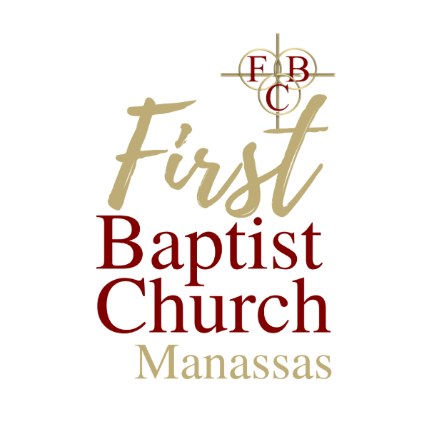
First Baptist Church
Manassas, VA

Dr. Keith A. Savage
Senior Servant

2023
Sample
Ballot
for
Church Officers

Clerk
(1 Seat)

Cynthia Ragland
__________________________
Assistant Clerk
(1 Seat)

Marion Carter
___________________________
Treasurer
(1 Seat)

Aaron Burrell
___________________________
Assistant Treasurer
(1 Seat)

Wilbur Rollins
___________________________
Financial Secretary (1 Seat)

Diana Kelly
Catherine Nickens
___________________________

Assistant Financial Secretary
(1 Seat)

Debbie Sykes

Trustee
(4 Seats – only select 4 names)

Curtis Bedford

Robert Benson

Udon Cheek

Carl Powell

Gregory Robinson

